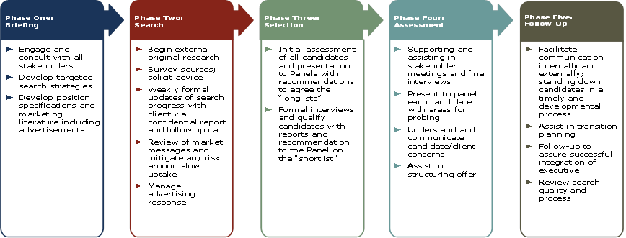

|  |  |
| --- | --- |
| **Activity** | **Week Commencing** |
| Phase One: Briefing | 8th January 2018 |
| Phase Two: Search | 15th January 2018 |
| Phase Three: Selection | 12th February 2018 |
| Phase Four: Assessment | 26th February 2018 |
| Phase Five: Follow-Up | 5th March 2018 |